Assignment 1

Problems: 1,2

Gahana Michele Resignac

CST-115-001-232

Box Office

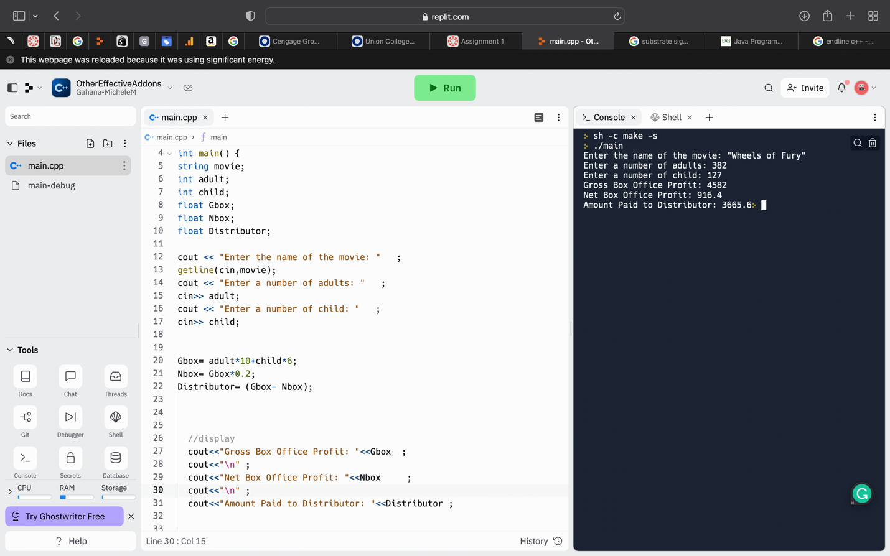

Interest Earned

